Module 10

#1. For 1024 of samples at 1m spacing intervals, the minimum wavelength that can be detected is 2m and the maximum wavelength is 1024m.

#2. Graphs of convolution as a function of wavenumber:

As the graphs are upwardly continued farther in height, the convolution places significantly more weight towards long-wavelength features. This means that anomalies seen at higher elevation have generally longer wavelengths than those seen at the surface, and this upward continuation can be used to enhance these longer features.

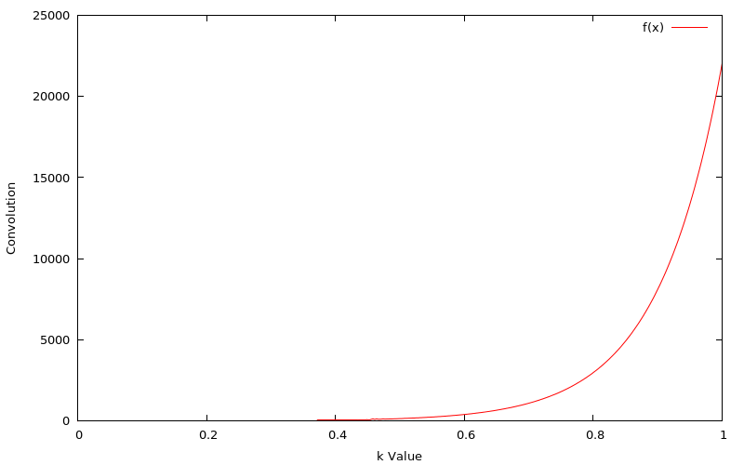

Figure 2-1: Graph of convolution for 10m upward continuation from 1/1024 to 1

Figure 2-2: Graph of convolution for 100m upward continuation from 1/1024 to 1

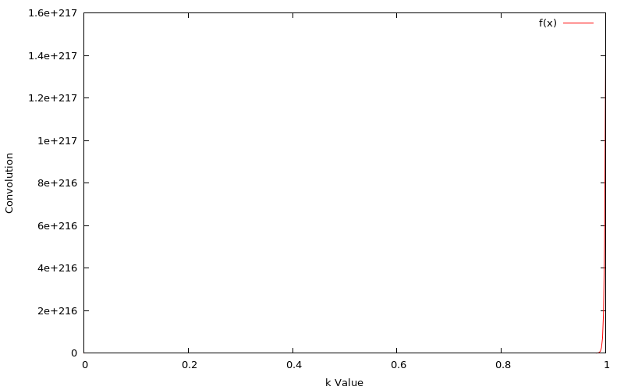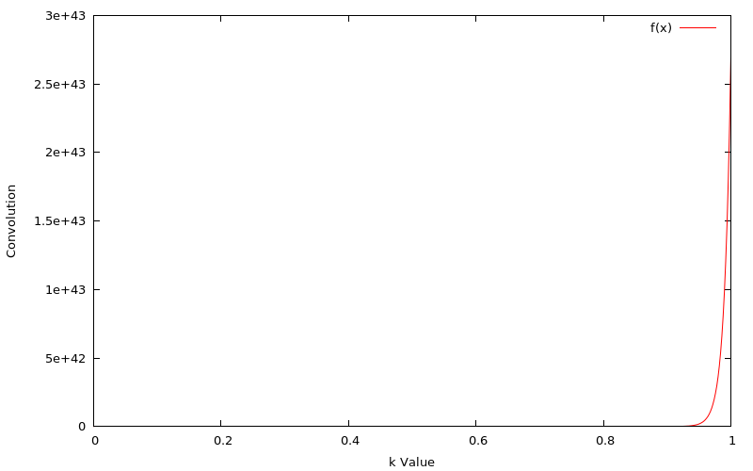

Figure 2-3: Graph of convolution for 500m upward continuation from 1/1024 to 1

#3. Plot of dike anomaly:

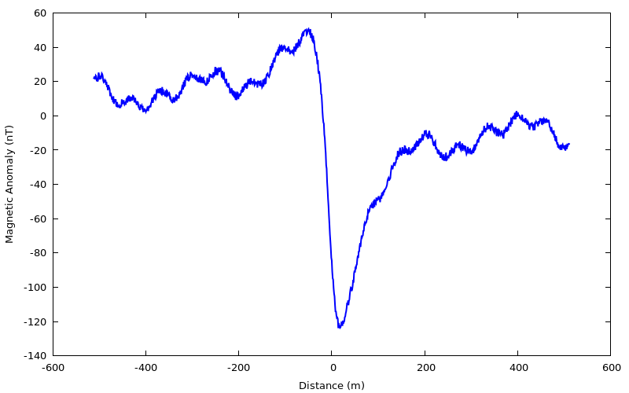

Figure 3: Plot of the magnetic anomaly associated with a dike. The dike is seen as a high-amplitude, long-wavelength feature with short-wavelength anomalies along the profile most likely associated with surface features.

#4. Plot of power spectrum:

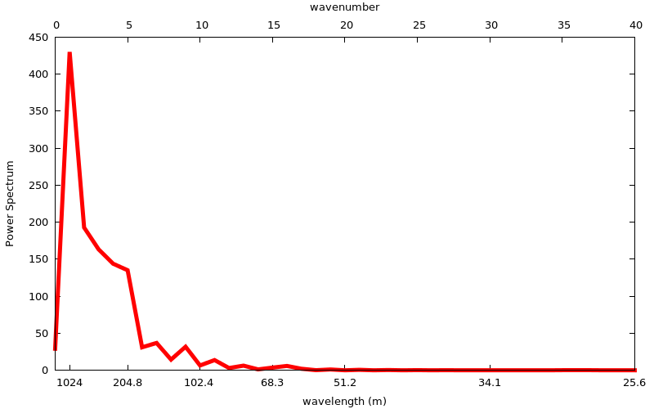

Figure 4: Power spectrum of the dike anomaly seen in Figure 3. The large-amplitude and long-wavelength dike anomaly can be seen as the large spike ranging from around 1024m to 200m. The smaller, short-wavelength features are seen as the smaller spikes at lower wavelength.

#5. I was unable to get a working plot for upward continuation, but would guess that an upward continuation in the range of 25-50m would enhance the anomaly of the dike well. This guess is based on the convolution plots as the 10m upward continuation would still show a lot of the short-wavelength features while the 100m may lose some of the 200m wavelength range of the dike anomaly.

#6. Low pass filtering plots

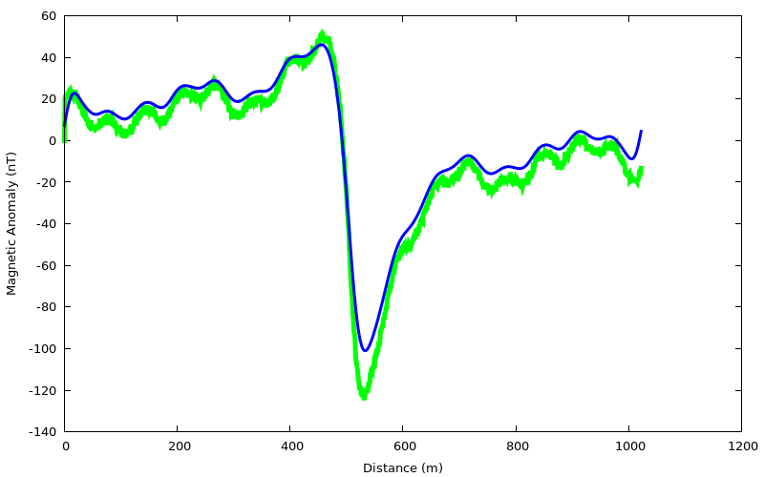

Figure 6-1: 25m low pass filter of dike anomaly. This low pass still includes a lot of the short wavelength features, so more of the data should be filtered.

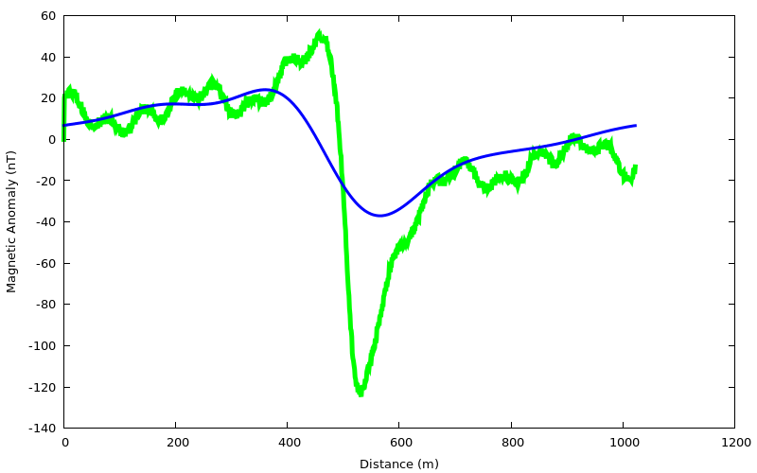

Figure 6-2: 150m low pass filter of dike anomaly. The short wavelength features have been removed, but too much of the dike anomaly has been removed by this filter.

Figure 6-3: 75m low pass filter of dike anomaly. This moderate low pass appears to give the best fit for the anomaly of the dike. It removes most of the higher frequency anomalies whiles still trending close to the plot of the data.

